(41) Daphne occulte TYC 0075-00715-1.

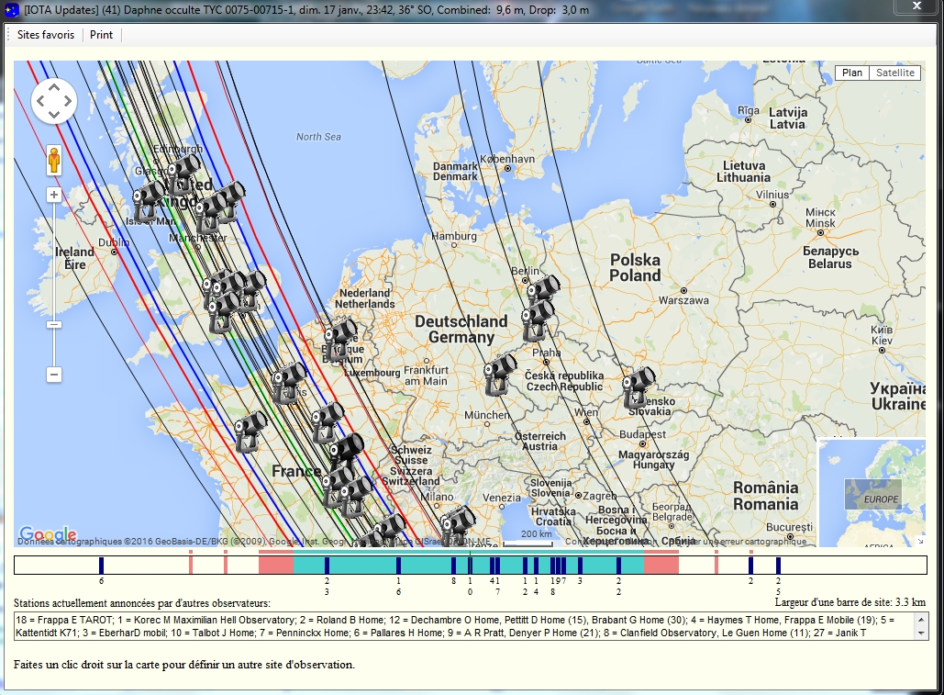

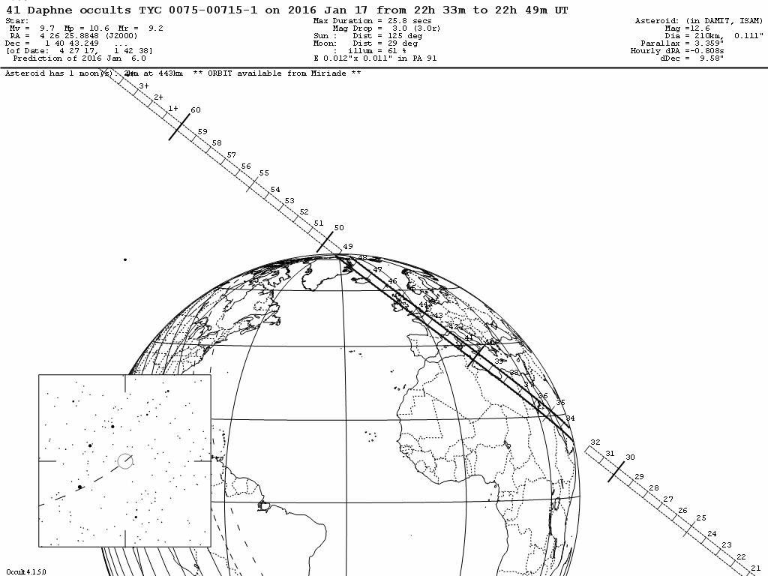
IOTA/IOTA-ES occultation update for
(41) Daphne / TYC 0075-00715-1 event on 2016 Jan 17, 22:41 UT
Visible from Arabia, N Africa, Europe

Summary
-------
On 2016 Jan 17 UT, the 210 km diameter asteroid (41) Daphne will occult a 9.7
mag star in the constellation Taurus for observers along a path across Arabia, N
Africa, Europe.

In the case of an occultation, the combined light of the asteroid and the star
will drop by 3.0 mag to 12.6 mag (the magnitude of the asteroid) for at most
25.8 seconds.

This update is based on UNSO/Flagstaff astrometry for the asteroid kindly
provided by Alice Monet, TMO astrometry for the asteroid kindly provided by Bill
Owen, historical astrometry from the MPC files (via AstDys), and the following
catalogs for the star position: UCAC.

The event at a glimpse
----------------------
* Rank: 100
* date and approx. time of event: 2016 Jan 17, 22:33 - 2016 Jan 17, 22:48 UT
* geocentric midpoint of event [JD]: 2457405.44512083
* magnitude of target star: 9.7
* magnitude drop [mag]: 3.0
* estimated maximum duration [s]: 25.8
* Moon: 60 % sunlit, 30° distance
* Sun: 125° distance
* rough path description: Arabia, N Africa, Europe

The occultation path
--------------------
* approximate projected width [km]: 343
* 1 sigma uncertainty interval [path widths]: +/- 0.10
* 1 sigma uncertainty interval [seconds]: +/- 2.7
* 1 sigma uncertainty interval approx RA,DE ["]: (+/- .012 +/- .011)
* 1 sigma uncertainty ellipse (major, minor, PA): ( .012", .011", 91° )
* approx speed of asteroid's shadow [km/s]: 8.1518
* website for maps:
http://www.asteroidoccultation.com

Uncertainty in time = +/- 3 secs

Prediction of 2016 Jan 6.0

Data for the target star
------------------------
* name: TYC 0075-00715-1
* constellation : Taurus
* J2000 position with proper motion to date of event [h,m,s ; °,',"]
RA: 04 26 25.8848 DE: +01 40 43.249
* position source: Pos: URAT1, pm: UCAC4, pi:
* standard error: RA,DE ["]: ( .009, .009 )
* V mag [mag]: 9.7
* B mag [mag]: 10.6
* Diameter [mas]: 0
* remarks:

Data for the minor planet
-------------------------
* general information:
(number) name: (41) Daphne
approx. diameter [km]: 210
approx. diameter ["]: .111
distance from Earth [AU]: 2.61800

* orbital information:
orbit source: Preston
date of fit: 2016 Jan 06
source of used astrometry: FASTT TMO MPC (via Astdys)
number of used observations: 1684
number of rejected observations: 168
time covered by the observations: 1915 Jan 08 - 2015 Dec 31
1 sigma uncertainty ellipse (major, minor, PA): 0.007, 0.006, 92°
remarks:

* orbital elements for (41) Daphne :
Mean anomaly = 237.38915308 deg
Arg. of pericenter = 45.97082715 deg
Long. of node = 178.09329119 deg
Inclination = 15.79654900 deg
Eccentricity = 0.27563636
Semimajor axis = 2.75954989 AU
Perihelion dist = 1.99891760 AU
Mag: H = 7.30, G = 0.10
Epoch of elements : MJD 57404.94500000 TDT
(2016 Jan 17.945)

------ occelmnt file for Occult BEGIN -----------------------------------
2016 Jan 17
41 Daphne
22h 41.0m UT
9.7 4 26 25.885 1 40 43.25TYC 0075-00715-1 10.6
12.6 210 25.8 2.618 -0.808 9.58
-30.4287 1.677 -157.72 -20.70
22.6829 0.48957 0.62055 -3.61245 2.84962 0.00451 0.00204
2000 236.3259582016 113.00000 45.970827178.093291 15.7965490.27563636 2.7595499 1.9989176 7.1 5.00.10
RATE 2.1500410 0.000000 0.000000 0.000000 0.0000000 0.0000000 0.0000000
Meas 0.012 0.011 91 1.10 0.011 1 2 443 0-2-1 057393.0020160117_0715-1
------ occelmnt file for Occult END -----------------------------------

============================================
Calculator (s): Steve Preston
Date of update: 2016 Jan 06, 15:29 UT

Steve Preston
7640 NE 32nd St
Medina, WA 98039
425-688-9965
mailto: stevepr@acm.org
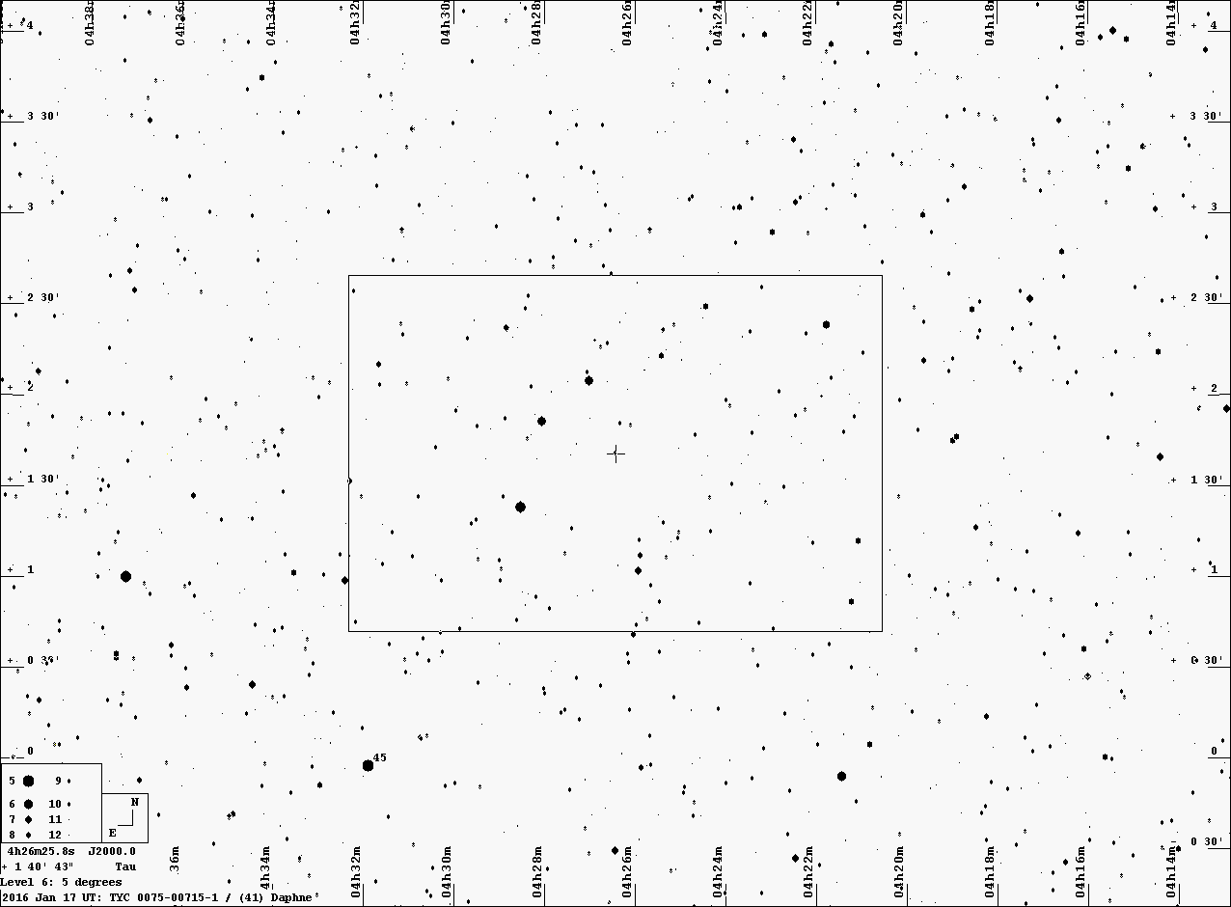
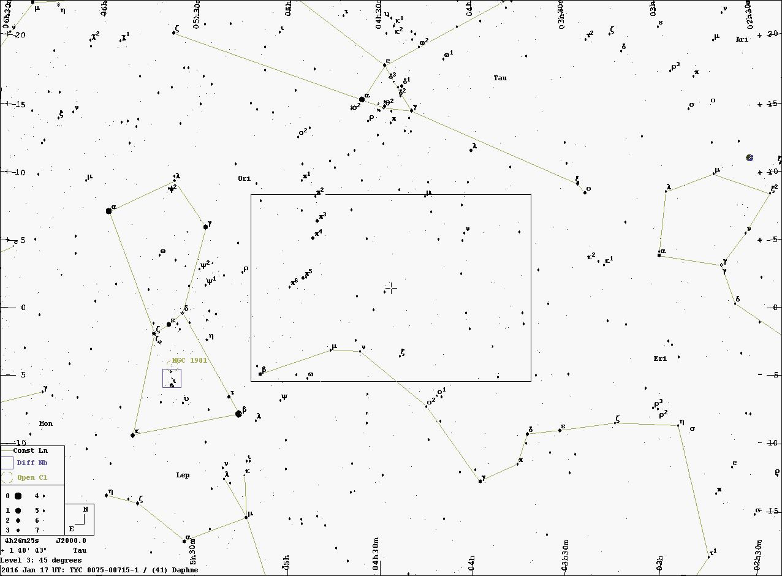

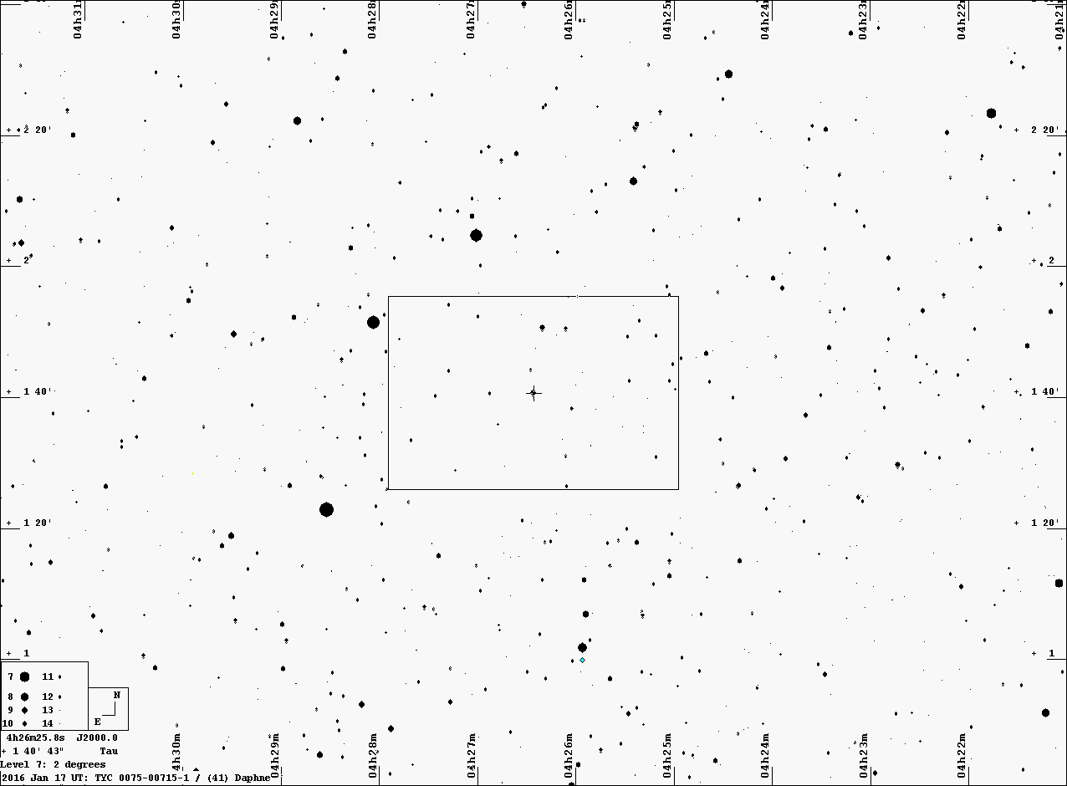

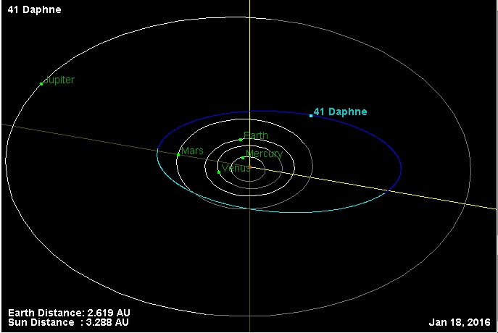
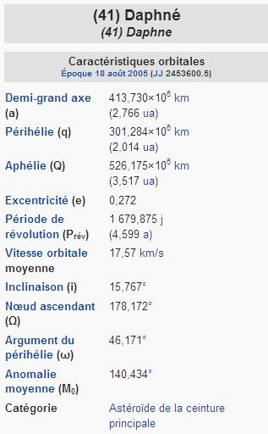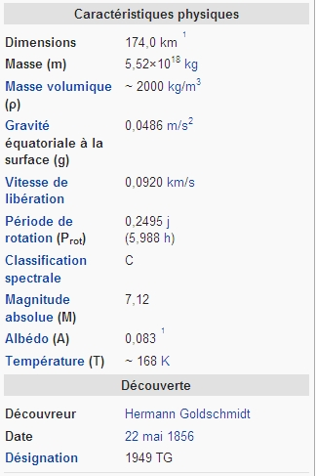

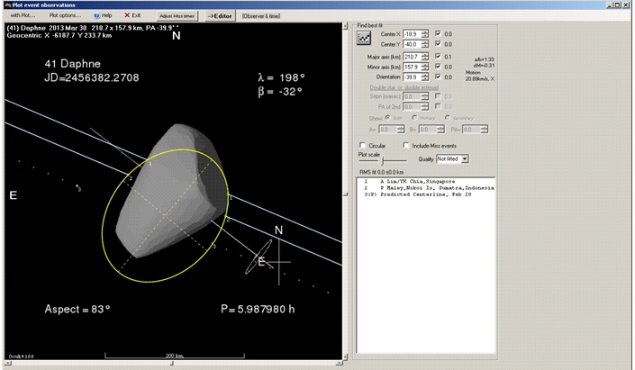
OCCULTATION OF HIP 93026 BY 41 Daphne
2013 March 30

OCCULTATION OF HIP 29994 BY 895 DAPHNE
2007 MAY 09

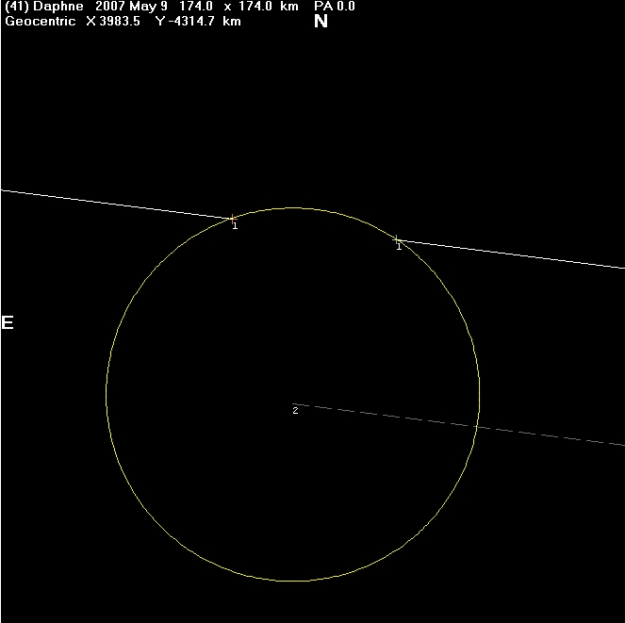
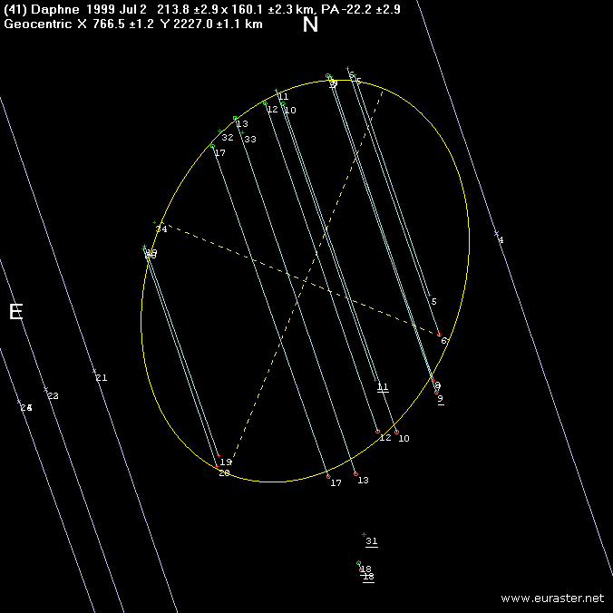

Et enfin les résultats de cette dernière occultation:

Avec la corde numéro 5 qui représente mon observation :